THE UNIVERSITY OF AZAD JAMMU & KASHMIR, MUZAFFARABAD


COURSE TITLE | SDA
COURSE CODE | SE-2102
TITLE | LAB # 2
STUDENT NAME | HASEEB SHEIKH
STUDENT ROLL NUMBER | 2024-SE-31
INSTRUCTOR NAME | ENGR. DANIYAL NAZIR
SUBMISSION DATE | OCT 30, 2025

DEPARTMENT OF SOFTWARE ENGINEERING
Contents

1. Introduction 3
1.1 Purpose 3
1.2 Scope 3
1.3 Definitions, Acronyms, and Abbreviations 4
1.4 References 4
2. Overall Description 4
2.1 Product Perspective 4
2.2 Product Functions 5
2.3 User Characteristics 5
3. Specific Requirements 6
3.1 Functional Requirements 6
3.2 Non-Functional Requirements 6
3.3 Design Constraints 7
3.4 Assumptions and Dependencies 7
4. System Models 8
4.1 Use Case Diagram: 8
4.2 Sequence Diagram: 8
Conclusion 9

Software Requirement Specification

1. Introduction

1.1 Purpose
The purpose of this document is to define the software requirements for the Student Data Organizer developed using C++ and Object-Oriented Programming (OOP) principles.
This project aims to efficiently manage student records, allowing users to add, view, search, update, and delete student details, while automatically calculating percentages.
The document will serve as a guide for developers, testers, and users.

1.2 Scope
The Student Data Organizer is a console-based C++ application designed to simplify student record management.
It allows a user (e.g., teacher or admin) to perform all CRUD operations—Create, Read, Update, Delete—on student records stored in files.
The system ensures data persistence, accuracy, and easy retrieval of information.
Main functionalities include:
- Adding new student records
- Viewing all records
- Searching for a student by roll number
- Updating an existing record
- Deleting a record
- Auto-calculating percentage and grade
The project applies Object-Oriented principles such as:
- Encapsulation (data hiding through classes)
- Abstraction (simplified user interaction)
- Inheritance (if extending functionalities)
- Polymorphism (flexible data handling or file operations)

1.3 Definitions, Acronyms, and Abbreviations

Term | Description
CRUD | Create, Read, Update, Delete
OOP | Object-Oriented Programming
SRS | Software Requirements Specification
I/O | Input/Output

1.4 References
• IEEE Std 830-1998, IEEE Recommended Practice for Software Requirements Specifications
• C++ Documentation (cppreference.com)
• Project Manual provided by Engr. Daniyal Nazir (Software Design & Architecture Lab Manual, 2025)

2. Overall Description

2.1 Product Perspective
2.1 Product Perspective
The Student Data Organizer is a stand-alone system that runs locally on a user’s computer.
It uses text files for data storage, eliminating the need for a database.
It follows a menu-driven console interface, guiding the user step-by-step.
System Environment:
- Language: C++
- Interface: Console
- Storage: File Handling (fstream)
- Platform: Windows ( Dev C++)

2.2 Product Functions

ID | Function Name | Description
F1 | Add Student Record | Allows user to input student details (name, roll no, marks).
F2 | View All Records | Displays all stored student records from file.
F3 | Search Record | Finds student by roll number.
F4 | Update Record | Modifies existing details (e.g., marks).
F5 | Delete Record | Removes a student record permanently.
F6 | Calculate Percentage | Automatically computes percentage and assigns grade.

2.3 User Characteristics
User Type | Description
Admin/Teacher | Primary user responsible for managing student data. Requires basic computer knowledge.
End User | Anyone who needs to maintain a record of students efficiently.

3. Specific Requirements

3.1 Functional Requirements
ID | Requirement Description
FR1 | System shall allow adding a new student record.
FR2 | System shall allow displaying all student records.
FR3 | System shall allow searching for a specific student by roll number.
FR4 | System shall allow editing/updating a student’s details.
FR5 | System shall allow deleting a student’s record.
FR6 | System shall automatically calculate percentage and grade based on marks.
FR7 | System shall store all records persistently in a file.
FR8 | System shall validate user input for data consistency.

3.2 Non-Functional Requirements
ID | Requirement Description
FR1 | System shall allow adding a new student record.
FR2 | System shall allow displaying all student records.
FR3 | System shall allow searching for a specific student by roll number.
FR4 | System shall allow editing/updating a student’s details.
FR5 | System shall allow deleting a student’s record.
FR6 | System shall automatically calculate percentage and grade based on marks.
FR7 | System shall store all records persistently in a file.
FR8 | System shall validate user input for data consistency.

3.3 Design Constraints

- The system must be implemented in C++ using OOP concepts.
- Data must be stored using file handling (no database).
- Operates in a text-based console interface.
- Input validation and error handling must be provided.

3.4 Assumptions and Dependencies

- User enters valid numeric data for marks.
- Text file permissions allow read/write operations.
- The program runs in a C++17-compatible environment.

4. System Models

4.1 Use Case Diagram:
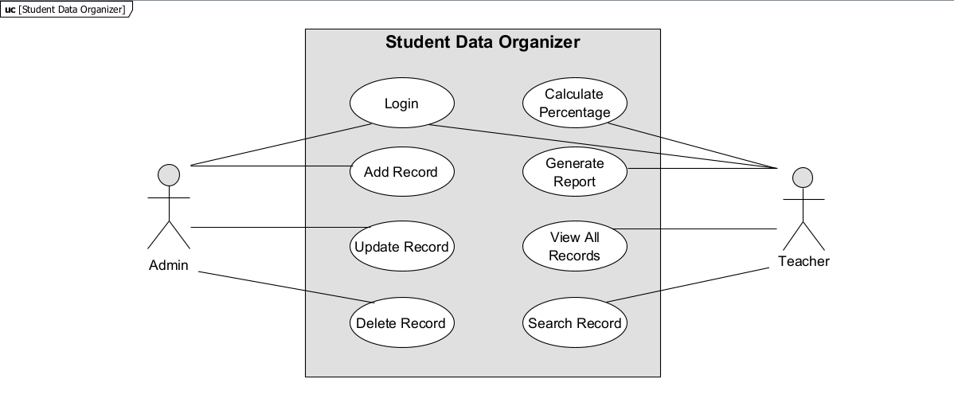

4.2 Sequence Diagram:
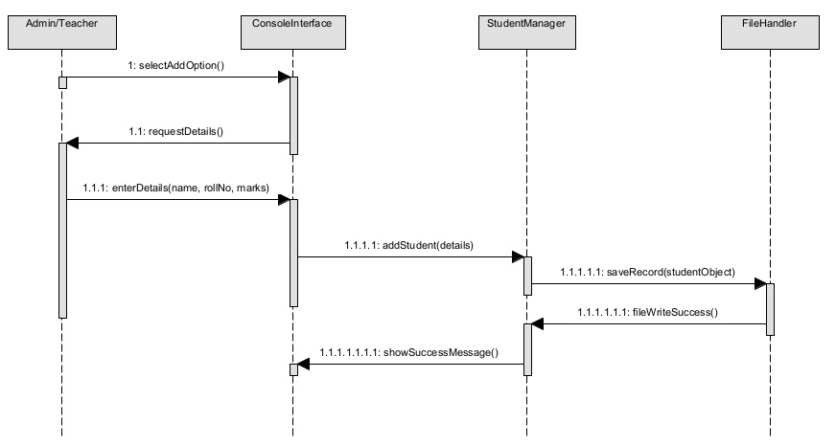

Conclusion
This SRS document outlines the functional and non-functional requirements for the OOP-Project software system. It defines the scope, user interactions, features, constraints, and assumptions. Moving forward, this document will serve as the baseline for design, implementation, testing, and validation of the system.

